PROJECT TITILE: SMART PUBLIC RESTROOMS

PHASE 5: PROJECT DOCUMENTATION AND SUBMISSION

Objectives :

* Improved Hygiene and Sanitation:
  + Implement touchless fixtures, including sensor-operated faucets, soap dispensers, and flush toilets, to reduce the risk of germ transmission.
  + Use antimicrobial materials and coatings for high-touch surfaces and fixtures to minimize the spread of pathogens.
  + Employ UV-C or other disinfection technologies to regularly sanitize restroom surfaces and air.
* Water and Energy Efficiency:
  + Install water-saving fixtures and toilets to reduce water consumption while maintaining sanitation standards.
  + Implement energy-efficient lighting, heating, and ventilation systems to minimize energy usage.
* Real-time Monitoring and Maintenance:
  + Utilize sensors and IoT devices to monitor restroom occupancy, detect issues such as leaks or clogs, and track supply levels (e.g., toilet paper, soap).
  + Implement predictive maintenance systems to schedule repairs and maintenance before major issues arise, ensuring restroom availability.
* Accessibility and Inclusivity:
  + Design restrooms to be accessible for individuals with disabilities, complying with ADA (Americans with Disabilities Act) requirements.
  + Offer features like gender-neutral facilities to accommodate diverse user preferences.
* Waste Management and Sustainability:
  + Implement waste sorting and recycling bins to encourage responsible waste disposal.
  + Use low-maintenance and sustainable building materials and technologies to reduce environmental impact.
* User-Friendly Interfaces:
  + Develop user-friendly interfaces or mobile apps to provide information about restroom availability, wait times, and cleanliness ratings.
  + Enable users to provide feedback or request assistance through digital platforms.
* Privacy and Security:
  + Ensure user privacy and security by employing secure data handling practices and preventing misuse of surveillance technology.
  + Provide adequate locks and security measures to ensure user safety.
* Smart Restroom Analytics:
  + Collect and analyze data on restroom usage patterns, peak hours, and customer feedback to optimize cleaning schedules and resource allocation.
  + Use analytics to make data-driven decisions and continuously improve restroom operations.
* Emergency Response and Safety:
  + Implement emergency call buttons or communication systems within restrooms to address safety concerns.
  + Ensure proper lighting and surveillance to deter illicit activities and enhance overall safety.
* Sustainability Initiatives:
  + Incorporate renewable energy sources, such as solar panels, to power restroom facilities.
  + Implement rainwater harvesting systems for toilet flushing and irrigation.
* Promote Public Health:
  + Provide informative displays on proper handwashing techniques and health-related information to educate users.
  + Encourage responsible behavior through signage and awareness campaigns.
* Customer Experience:
  + Focus on creating a positive and comfortable user experience through well-maintained facilities, pleasing aesthetics, and high-quality amenities.
* Adaptation to Local Needs:
  + Tailor smart restroom solutions to the specific needs and cultural expectations of the location and user demographics.

By setting and achieving these objectives, smart public restrooms can enhance user satisfaction, reduce operational costs, and contribute to overall public health and well-being.

## IOT SESOR DEPLOYMENT:

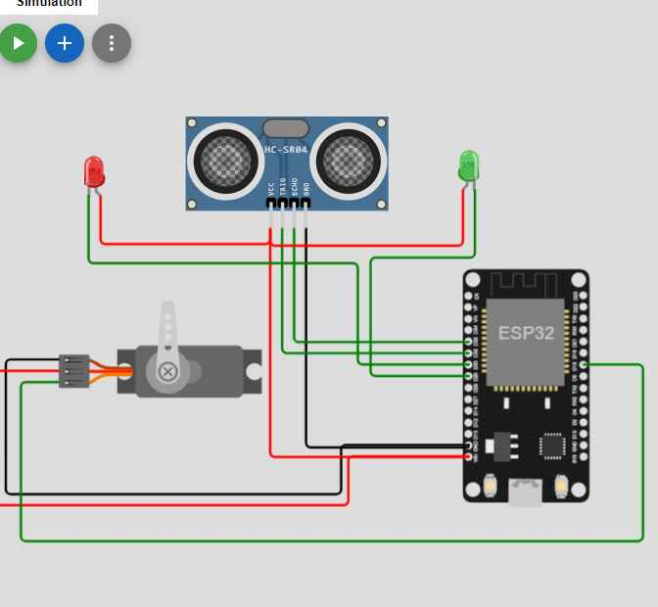

**Create by Wokwi**

## WOKWI DESCRIPTIOON:

#include<ESP32Servo.h>

#define TRIGGERPIN 32

#define ECHOPIN 35

#define RED_LED 33

#define GREEN_LED 25

Servo servo_1;

long duration;

int pos, distance, i=0;

void setup()

{

servo_1.attach(18);

**Serial**.begin(115200);

pinMode(TRIGGERPIN, OUTPUT);

pinMode(ECHOPIN, INPUT);

pinMode(RED_LED, OUTPUT);

pinMode(GREEN_LED, OUTPUT);

**Serial**.println(" ");

**Serial**.println("Sensing the Height");

digitalWrite(RED_LED, HIGH);

digitalWrite(GREEN_LED, LOW);

pos = 0;

servo_1.write(pos);

}

void loop()

{

digitalWrite(TRIGGERPIN, LOW);

delayMicroseconds(3);

digitalWrite(TRIGGERPIN, HIGH);

delayMicroseconds(12); // it may be 10 us

digitalWrite(TRIGGERPIN, LOW);

// Reads the echoPin, returns the sound wave travel time in microseconds

duration = pulseIn(ECHOPIN, HIGH);

// Calculating the distance

distance = (duration/2) / 29.1;

// for Adult

if (distance >= 100 && distance <= 150)

{

i = 1;

if (pos != 180)

{

servo_1.write(180);

pos = 180;

i = 1;

}

}

// for Child

else if (distance >= 200 && distance <= 250)

{

i = 1;

if (pos != 0)

{

servo_1.write(0);

pos = 0;

i = 1;

}

}

else if (distance > 300 && i == 1)

{

digitalWrite(RED_LED, LOW);

digitalWrite(GREEN_LED, HIGH);

delay(5000);

digitalWrite(RED_LED, HIGH);

digitalWrite(GREEN_LED, LOW);

i = 0;

}

delay (500);

**Serial**.println(" ");

**Serial**.print("Free Level : ");

**Serial**.print(distance);

**Serial**.print(" ");

**Serial**.print("Position : ");

**Serial**.print(pos);

delay (500);

}

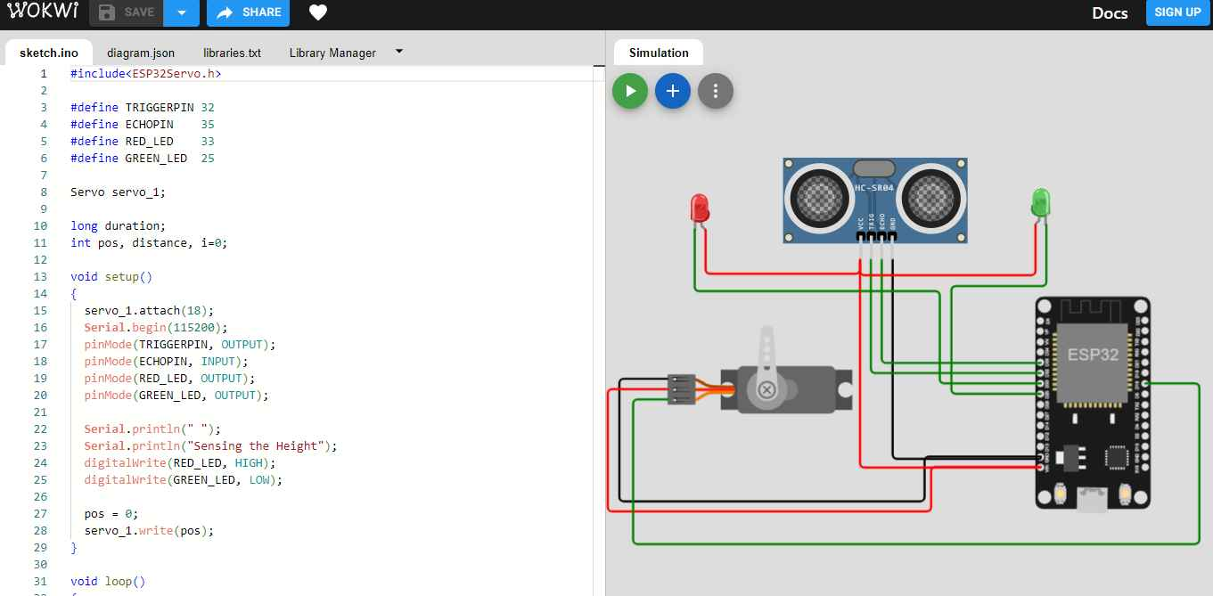

PLATFORM DEVELOPMENT:

## IoT Hardware Components:

* Sensors:
  + Occupancy sensors: Detect the presence of users to monitor restroom occupancy.
  + Proximity sensors: Trigger touchless fixtures, such as faucets, soap dispensers, and flush toilets.
  + Environmental sensors: Measure temperature, humidity, and air quality for optimal comfort and efficiency.
* Touchless Fixtures:
  + Sensor-operated faucets: Enable touchless handwashing.
  + Sensor-operated soap dispensers: Dispense soap without physical contact.
  + Touchless flush toilets and urinals: Automatically flush after use.
* IoT (Internet of Things) Devices:
  + Smart locks: Ensure restroom security and control access.
  + IoT controllers and hubs: Connect and manage various devices and sensors within the restroom.
  + IoT gateways: Facilitate communication between restroom devices and the central management system.
* Surveillance and Security Systems:
  + CCTV cameras: Monitor activity inside and outside the restroom for safety and security.
  + Access control systems: Provide secure access to the restroom using access cards, PIN codes, or biometric recognition.
* HVAC and Ventilation Systems:
  + Smart thermostats and HVAC controllers: Regulate temperature for user comfort and energy efficiency.
  + Ventilation systems: Ensure proper air circulation and quality.
  + Carbon monoxide and smoke detectors: Enhance safety by detecting hazards.
* Lighting:
  + Motion-activated LED lighting: Illuminate the restroom when occupied and save energy when unoccupied.
  + Emergency lighting: Activate during power outages or emergencies.
* Waste Management and Recycling:
  + Smart waste bins: Use sensors to monitor waste levels and optimize collection schedules.
  + Recycling bins: Separate recyclables from general waste.
* Data Connectivity:
  + Wi-Fi routers or access points: Ensure connectivity for IoT devices and user interfaces.
  + Ethernet cabling: Provide stable network connections.
* Hand Dryers:
  + High-efficiency hand dryers: Offer touchless and energy-efficient hand drying options.
* Audio and Communication Systems:
  + Intercom or communication systems: Allow users to request assistance or report issues.
  + Public address systems: Convey important announcements and information.
* Emergency Call Buttons:
  + Install emergency call buttons for users to summon help during urgent situations.
* Solar Panels (optional):
  + Solar panels can provide renewable energy to power the restroom's electrical components, reducing the reliance on the grid.
* Digital Displays and Signage:
  + Digital information screens: Display restroom availability, cleaning schedules, and hygiene information.
  + Digital advertising displays (optional): Generate revenue through advertising partnerships.
* Water Conservation Systems:
  + Water-saving fixtures: Low-flow faucets, showers, and toilets to reduce water usage.
  + Water quality monitoring systems: Ensure safe and clean water supply.
* Power Management Systems:
  + Uninterruptible Power Supply (UPS): Provide backup power to critical systems during outages.
  + Power distribution units (PDUs): Safely distribute electrical power to various components.
* Maintenance and Monitoring Tools:
  + Remote monitoring and management software: Control and monitor restroom functions and devices.
  + Diagnostic tools and equipment for regular maintenance and repairs.

Selecting the appropriate hardware components is critical for the success of a smart public restroom project. These components should be integrated and configured to meet the project's objectives and provide a seamless and efficient user experience.

HTML

<!DOCTYPE html>

<html>

<head>

<meta charset="UTF-8">

<title>My Web Page</title>

</head>

<body>

<h1>This is a Heading 1</h1>

<h2>This is a Heading 2</h2>

<p>This is a paragraph of text.</p>

<a href="https://www.example.com">Visit Example</a>

<ul>

<li>Item 1</li>

<li>Item 2</li>

</ul>

<ol>

<li>First item</li>

<li>Second item</li>

</ol>

<img src="image.jpg" alt="Description of the image">

<form action="submit.php" method="post">

<label for="username">Username:</label>

<input type="text" id="username" name="username">

<br>

<label for="password">Password:</label>

<input type="password" id="password" name="password">

<br>

<input type="submit" value="Submit">

</form>

<table>

<tr>

<th>Header 1</th>

<th>Header 2</th>

</tr>

<tr>

<td>Data 1</td>

<td>Data 2</td>

</tr>

</table>

<div id="container">

<p>This is a div with an ID.</p>

</div>

<div class="section">

<p>This is a div with a class.</p>

</div>

<!-- This is a comment. -->

</body>

</html>

Result analysis:

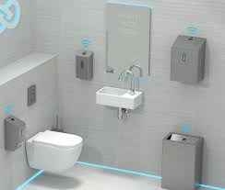

**EXPLANATION:**

A smart public restroom is an innovative and technologically advanced facility designed to enhance user convenience, hygiene, and overall experience. By integrating various high-tech components and features, these restrooms aim to improve sanitation through touchless fixtures, automatic flush toilets, and regular UV-C disinfection. They also prioritize water and energy efficiency, using sensors to optimize resource usage. Real-time monitoring and maintenance systems ensure cleanliness and functionality, while accessibility features cater to diverse user needs, including individuals with disabilities. Smart restrooms promote sustainability by incorporating waste management and recycling solutions, sustainable building materials, and even renewable energy sources like solar panels. User-friendly interfaces and mobile apps provide information about availability and cleanliness, while emergency response systems and security measures ensure user safety. Collecting data on usage patterns and customer feedback allows for data-driven decision-making, further enhancing the overall user experience and public health. In essence, smart public restrooms represent a holistic approach to public facilities, offering improved hygiene, resource efficiency, accessibility, and user satisfaction through the power of technology.

**Conclusion:**

In conclusion, smart public restrooms represent a significant step forward in reimagining and improving the quality of public facilities. By harnessing cutting-edge technology and sustainable practices, these restrooms offer a multitude of benefits, including enhanced sanitation, efficient resource usage, accessibility, and user satisfaction. The integration of touchless fixtures, environmental sensors, and real-time monitoring systems ensures a high level of hygiene and safety. Moreover, these facilities play a role in reducing environmental impact by incorporating waste management solutions and sustainable materials.

The user experience is further improved through user-friendly interfaces and data-driven decision-making, making it more convenient and informative. The smart public restroom concept not only focuses on meeting basic needs but also fosters a sense of well-being and inclusivity, as it caters to various user demographics, including those with disabilities. With these objectives and technologies, smart public restrooms set a new standard for public facilities, emphasizing the importance of hygiene, sustainability, and user satisfaction in our everyday lives.